**Brief Introduction**

HIGHLY AUTOMATIC PHOTOGRAPHER ROBOT is a robot that can help user to take portrait photo, when there is no photographer available, or you do not trust the guy who is holding the camera : ).

And even though digital camera is very important to record the meaningful, unforgettable moment, a camera is just a dumb tool, which cannot serve as intelligent photographer. Also, on one hand, sometimes it’s hard to find someone else to take photo for you. For example, you are traveling alone and enjoying the beautiful scenery. Suddenly you are impressed and want to memorize the moment; or you and friends or families are having parties at which a group photo is expected; you joys may be ruined by the lack of photographer. On the other hand, you may have a top grade Single Lens Reflex Camera; but you cannot take full advantage of it if you are inexperienced.

In order to improve these situations, we design and implement a HIGHLY AUTOMATIC PHOTOGRAPHER ROBOT. This robot is your personal professional photographer, which utilize the camera and give you a satisfactory solution. It will automatically target the camera at you, and find the perfect orientation and position so that you looks the most harmonious in the whole picture together with the background you selected. All you need to do is to power on the robot and run the App in your android phone to order the robot to start. After it has finished adjustment, it will notify you via your phone, and you can make the final call whether the current picture shown on your phone satisfies you.

**Abstract**

Highly Automatic Photography Robot is a robot that can help user to take portrait photo when there is no photographer available, or you do not trust the guy who is holding the camera : ) . Sometimes you will travel alone, and cannot find any passer-by to help you to take a photo to memorize your excellent trip. [PLEASE ADD OTHER POSSIBLE SITUATION THIS ROBOT WILL BE USED]When in these awkward situations, this robot can be of great help. It will automatically target the camera at you, and find the perfect orientation and position so that you looks the most harmonious in the whole picture together with the background you selected. All you need to do is to power on the robot and open the App in your android phone to order it to start. After it has done adjustment, it will notify you via your phone, and you can make the final call whether the current picture shown on your phone satisfy you.

**Chapter 1 Introduction**

**Background**

**System Overview**

**Control Flow of the robot**

**Chapter 2 User Interface and Camera Interface**

**Chapter 3 Image Analysis and Motion Planning**

**Chapter 4 Motion Controlling System**

**Chapter 5 Testing**

**Chapter 1 Introduction**

**figure [num] The robot**

**System Overview:**

The following diagram shows the basic three physical components of this robot, they are camera, the development board, and the car.

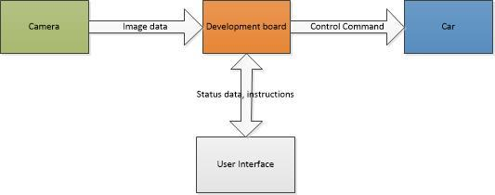

figure [num] The overall diagram of the system.

The camera is responsible for taking photos and passing the image data to the development board.

The development board is doing image analysis and motion planning, it is the brain of the whole system.

The car carries out the command given by the development board, like going forward, rotate degree, to have the next image (photo) closer to the expected one.

The user interface is a cell phone with android OS installed, running an APP written by us, it’s a bridge between the user and the robot, so that the user could know what the robot is doing, and retrieve the photo when necessary.

More detailed description of these components would be presented in the following chapter.